**Experiment: 7**

PART A

(PART A: TO BE REFFERED BY STUDENTS)

**Aim:** **To study concept of two-dimensional arrays in C++ programming**

**Learning Outcomes: Learner would be able to**

1. Interpret the scenario to decide on selective and repetitive blocks.
2. Explain using algorithm and flowchart working of 2-D array as per scenario.

**Task 1: What is the output of the following?**

void main()

{

int a[2][3] = {1, 2, 3, 4, 5};

int i = 0, j = 0;

for (i = 0; i < 2; i++)

for (j = 0; j < 3; j++)

cout<<a[i][j];

}

**Task 2:** Write a program to take values for 2-dimensional array and to give choice to the user for performing below operations:

1. Sum of elements of each row.

2. Sum of diagonal elements.

3. Finding transpose of matrix.

**Task 3:** Develop, implement and execute a C++ program that reads two matrices A (m x n ) and B (p x q ) and Compute the product A and B. Read matrix A and matrix B in row major order and in column major order respectively. Print both the input matrices and resultant matrix with suitable headings and output should be in matrix format only. Program must check the compatibility of orders of the matrices for multiplication. Report appropriate message in case of incompatibility.

**Theory:**

**Two Dimensional Array: -** It is used to store data in matrix or tabular form.

**Declaring Two Dimensional Array:** We must declare two dimensional array before use, and following is the syntax:

**Syntax:-**

data_type arr_name[r_size][c_size];

**In above syntax,**

* data_type-can be “char” , “int”, “float” or “double”.
* arr_name-is similar to normal variables name.
* r_size- is the row size. & c_size is the column size.

Some example of two dimensional arrays are:

int arr[5][5];

char month [12][10];

char stud_name[60][20];

double salary[100][12];

Example: int x[3][4]

x is a two-dimensional (2d) array. The array can hold 12 elements. You can think the array as table with 3 row and each row has 4 column.

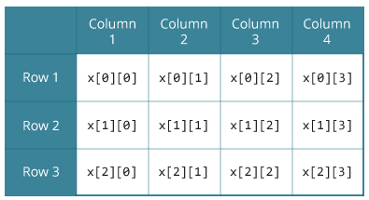

PART B

(PART B: TO BE COMPLETED BY STUDENTS)

Students must submit the soft copy as per following segments within two hours of the practical. The soft copy must be uploaded on the portal at the end of the practical. The filename should be **PPS_batch_rollno_experimentno Example: PPS_B2_B001_Exp1**

|  |  |
| --- | --- |
| **Roll No.:** | **Name:** |
| **Prog/Yr/Sem:** | **Batch:** |
| **Date of Experiment:** | **Date of Submission:** |

**Task 1:**

**Task 2:**

**Task 3:**

**Task 4:**

**Conclusion (Learning Outcomes):** Reflect on the questions answered by you jot down your learnings about the Topic: Two-dimensional array.

**Home Work Questions:**

Write a C++ program to add two matrices.